Report of the Joint Inspection Team on its visit to Tripura during 1st to 5th September, 2015 to review the progress under the Mission for Integrated Development of Horticulture (MIDH)

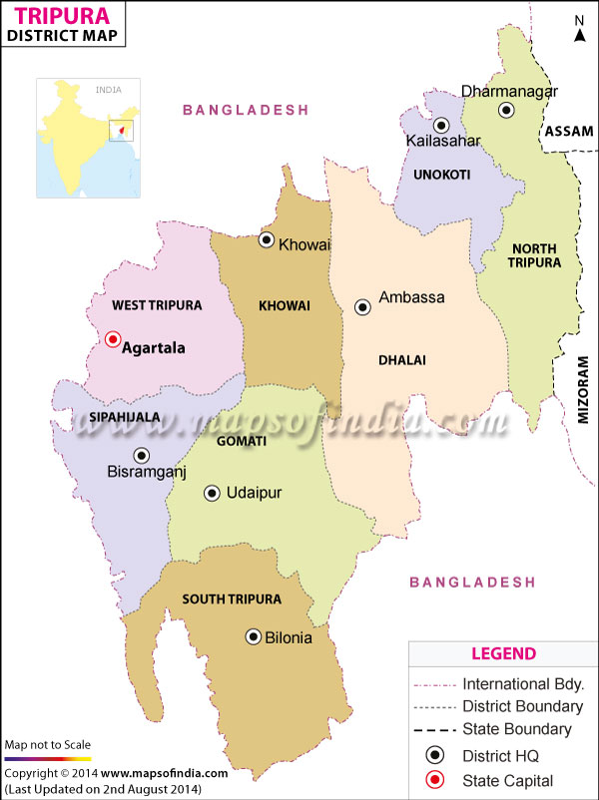

Districts visited by J.I.T

1. Sephijala district 2. South Tripura district


Mission for Integrated Development of Horticulture
Ministry of Agriculture
Department of Agriculture & Cooperation
Krishi Bhawan, New Delhi-110001

Table of contents
________________________________________________________________
Item Page No________

Actionable Issues and Observations made by JIT 3-5

INTRODUCTION 6

STATE PROFILE OF TRIPURA 6-9

Status of Horticulture in Tripura 10-12

VISIT OF JIT IN TRIPURA

Visit to Sephijala District 13-15

South Tripura district 16-17

Photographs 19

ACTIONABLE ISSUES

- The marketing linkages should be strengthened by making the FPOs.
- There is a need to establish processing facilities like extraction of juice & packing centre in the vegetable and fruit clusters especially in pineapple & lemon clusters for value addition.
- Community based area expansion programmes need to be augmented in all districts of the State.
- More area need to be brought under pineapple cultivation as the potential exists in visiting districts, accordingly training to farmers /field staff on cultivation aspects should be imparted along with technical support. The installation of drip / sprinkler needs to be supported with training on water management. Staggering technique needs to be augmented in a big way to increase the production period of pineapple.
- Existing nurseries required accreditation for producing quality planting material especially of citrus and new hybrid varieties of coconut.
- The farmers need to be trained at the grass root level regarding cultural practices like removal of water shoots, training and prunning of established plants and proper care for pest regulation during the initial growth period.
- Guava plantation needs proper control measure before appearance of disease.
- The new private nursery should also be encouraged by giving the assistance and proper guidance to produce more coconut seedlings as the demand is increasing in the State. Garden tool-kit should be provided to the farmers involved in nursery raising and cut-flower production.
- State should arrange to upload the monthly NHM physical and financial progress of the district level on the MIDH web site on regular basis.

OBSERVATIONS

- The farmers are resource poor and do not have funds to pool their share to get benefits of MIDH scheme. As result, per unit of operational cost is more which needs more funds.
- Targets are not achieved under NMMI in the State.
- Performance under Mango Cv. Amrapali is good in the state. The grower should be trained on canopy and Insect-Pest Management (IPM).
- Mosambi cultivation has a good prospects in the State.
- The height of grafted/budded mosambi plants should be proper at the time of distribution to avoid mortality and should be inspected properly for viral/diseases.
- Plantation of off-season watermelon is very good and in lieu, farmers can get high price.
- It was observed that proper training and pruning operation in Fruit crops (sweet orange, guava, mango and lemon) is not being done by the beneficiaries. The proper demonstrations and trainings should be given to beneficiaries so that the productivity of the orchards can be increased through scientific cultivation.
- The farmers are growing the pineapple in the rainfed conditions resulting in low productivity. Drip irrigation should be introduced in the pineapple field. At present, there is no processing and value addition in the pineapple cluster. As a result, the farmers are getting lower price for their produce. Establishment of processing unit in respect of pineapple should be encouraged for value-addition.
- The farmers are growing Gerbera, Anthurium, orchid, gladolus under protected conditions. Each shade net was 100 sqm area and the cut flowers are being sent to Agartala market.
- There is a weak market linkage resulting into lower prices of flowers to the farmers under protected cultivation. There is no collection centre and FPOs in the cluster for flowers.
- Community based area expansion programme of fruits like citrus, mango & guava under Panchayat land (patta) is being practised, efforts made by the horticulture Department in establishing fruit cluster are a welcome sign.
- Under paddy land, winter vegetables are grown with the State intervention of funding for mini tube well with submersible pump irrigation in the districts. It is indeed a good work done by SHM.
- Citrus planting material was found badly damaged with bacterial and viral disease beside insect problems.
- Fruit canker and die back of guava is a serious problem as informed by the farmers.

Report of the Joint Inspection Team on its visit to Tripura during 1 to 5th September, 2015 to review the progress under the Mission for Integrated Development of Horticulture

The Joint Inspection Team (JIT) comprising of Dr. Om Prakash, Chief Consultant, MIDH, DAC, Govt. of India, New Delhi, Dr. B. Das, Principal Scientist (Hort.), ICAR Research Complex for NEH Regions, Tripura Centre, Lembucherra, Tripura West and Vishnu Pada Chakraborty (AD), Horticulture Department, Govt. of Tripura joined the team and coordinated the entire visit of JIT.

STATE PROFILE
Tripura is one of the seven states in the north eastern part of India located between 22 degree and 56 minutes and 24 degree and 32 minutes north latitude and between 90 degree and 09 minutes and 92 degree and 20 minutes east latitude. It is bounded on the north, west, south and south-east by Bangladesh whereas in the east it has a common boundary with Assam and Mizoram. There is a common belief that the name of the State has originated from "Tripura Sundari" - the presiding deity of the land which is famous as one of the 51 pethos of Hindu Pilgrims. Apart from this traditional view, it is believed that originally the land was known as "Tuipra" meaning a land adjoining the water. It is fact that in days of yore the boundaries of Tripura were extended up to the Bay of Bengal when its rulers held sway from Garo hills to Arakan. The history of Tripura as an administrative unit dates back to the days of Maharajas when the territory was a native State. It is significant to note that all though Tripura was conquered by force of arms in 1761, no Political agents was appointed in the State till 1871 - a gap of 110 years.
The former princely state of Tripura was ruled by Maharajas of Manikya dynasty. It was an independent administrative unit under the Maharaja even during the British rule in India though this independence was qualified, being subject to the recognition of the British, as the paramount power, of each successive ruler. After independence of India, an agreement of merger of Tripura with the Indian Union was signed by the Regent Maharani on September 9, 1947 and the administration of the state was actually taken over by the Govt. of India on October 15, 1949. Tripura became a Union Territory without legislature with effect from November 1, 1956 and a popular ministry was installed in Tripura on July 1, 1963. On January 21, 1972 Tripura attained statehood.
Location | Remotest in the North East Region, 22º 56' ; 24º 32' North and 91º 09' and 92º 20' East.
Land | Total area 10.492 Sq. Km., International Border with Bangladesh-856 Km, Border with Mizoram-109 Km and with Assam-53 Km.
Land | 60% Hilly Terrain, 60% Forest area (39% Reserve Forest)
Land | 24% Net Sown Area
Land | Average size of Holding 0.56 Hectare.
Land | Irrigation 42% of Net Cropped area.
Climate | Temperature varies between 10 to 35 Degree Celsius,
Climate | Average Annual Rainfall 2,200mm,
Population | Total Population 31,99,203 as per 2001 Census,
Population | Rural Population 26,53,453
Population | Urban Population 5,45,750.
Population | Male 16,42,225
Population | Female 15,56,978.
Population | Population Density 305 per sq. Km.,
Population | Schedule Caste-5,55,724 Schedule Tribe-9,93,426
Population | Sex ratio-948
Population | Overall literacy rate(%)- 73.2
Major Language | Bengali, Kakborak and English.
Economy | The economy is primarily agrarian. The primary sector (Agricultural) contributes about 64% of total employment in the state and about 23% of the State Domestic Product (SDP).
Economy | A variety of Horticultural/ Plantation Crops are produced in Tripura like Pineapple, Orange, Cashew nut, Jackfruit, Coconut, Tea, Rubber, Forest , Plantations etc. There is ample scope for increasing the area under such plantations as well as the productivity.

Agricultural Scenario of Tripura

Area |  |  | 2009 - 10
a) | Total area of the State |  | 10,491.69 SqKms
b) | Altitude of Agartala |  | 12.80 Mts
c) | Location
 | i) | North latitude | 22º56' & 24º32'
 | ii ) | East longitude | 91º09' & 92º20'
 | iii ) | Extreme length | 183.5 Kms
 | iv) | Extreme width | 112.7 Kms
 | v ) | Border with Bangladesh | 856 Kms
 | vi ) | Border with Mizoram | 109 Kms
 | vii ) | Border with Assam | 53 Kms
d) | Land Utilisation
 | i ) | Total geographical area | 10,43,169 ha.
 | ii ) | Net area sown | 2,55,524 ha.
 | iii ) | Forest area | 6.29,429 ha.
 | iv ) | Area sown more than once | 1,92,968 ha.
 | v ) | Gross area sown | 4,48,492 ha.
 | vi) | Cropping intensity | 176%
Agriculture
a | Production of crops
 | i | Rice | 6,40,034 MT
 | ii | Wheat | 1,323 MT
 | iii | Maize | 2.030 MT
 | iv | Pulses | 4323 MT
 | Total Foodgrains |  | 6,47,710 MT
 | v | Sugar cane | 44,913 MT
 | vi | Cotton (Bale =170 kg) | 1,438 Bales
 | vii | Jute (Bale =180 kg) | 4,139 Bales
 | viii | Mesta (Bale =180 kg) | 6,522 Bales
 | ix | Total oil seeds | 2,483 MT
 | x | Potato | 94,554 MT
b | Fertilizer consumption |  | 35133 MT
c | Per hectare use of fertilizer (NPK) |  | 42 Kg/Ha
d | Bio-fertilizer distribution |  | 17 MT
e | Farmers trained |  | 70,000 Nos.
f | Regulated agricultural markets |  | 21
g | Cropping intensity (%) |  | 176%
h | Jhum productivity |  | 991 Kg/Ha
i | Cold Storage |  | 10 Nos.
j | Mango |  | 11,924.35 MT
k | Pineapple |  | 1,08,009 MT
l | Orange |  | 20,383 MT
m | Jackfruit |  | 2,52,384 MT
n | Coconut |  | 7,882 MT
o | Summer vegetable |  | 1,43,665,66 MT
p | Others winter vegetable |  | 1,62,602.05 MT
q | Kisan Credit Card issued |  | 30,469 Nos
r | Amount disbursed |  | Rs. 84.96 Crores
Climate
a | Normal annual rainfall |  | 2,169.40 mm
b | Average actual annual rainfall |  | 1,961.80 mm
c | Normal rainy days |  | 99.2
d | Actual rainy days |  | 82.5
Irrigation
a | Cultivable area |  | 2,79,050 ha.
b | Irrigable area |  | 1,17,000 ha.
c | Potential created |  | 10,4995 ha.
d | Potential utilized |  | 68,085 ha.

STATUS OF HORTICULTURE IN TRIPURA

Tripura produces about 1.50 m MT of horticulture produce from an area of 0.12 m ha. Major horticulture produce comprises fruit (46.4%) and vegetables (50.1%).

Mission for Integrated Development of Horticulture (MIDH)

The Centrally Sponsored Scheme of Horticulture Mission for North East and Himalayan States (HMNEH) is being implemented in Tripura since 2001-02. From April, 2014 onwards, HMNEH has been subsumed under Mission for Integrated Development of Horticulture (MIDH) for holistic growth of the horticulture sector covering fruits, vegetables, root and tuber crops, mushrooms, sp[ices, flowers, aromatic plants and plantation crops.

Implementation of Horticulture Mission for North East and Himalyan States (HMENH) in Tripura

The Centrally Sponsored Scheme of Horticulture Mission for North East and Himalayan States (HMNEH) is being implemented in all the districts of the state thereby covering important horticulture crops.

Progress till 2014-15
Salient physical progress till 2014-15 is as follows:-
- An additional area of 97803 ha of identified horticulture corps have been covered.
- In all, 197 nurseries have been established for production of quality planting material.
- An area of 8785 ha has been covered under rejuvenation of old and senile orchards.
- Setting up of 4 IPM/INM infrastructure facilities such as Leaf tissue analysis labs, diseases forecasting units.
- Organic farming has been adopted in an area of 2298 ha for promotion of organic cultivation of horticultural crops. Besides, 6682 vermi compost units have been set up.
- An area of 6.37 ha has been covered under protected cultivation.
- 52277 farmers have been trained under various horticulture activities.
- Work to be initiated for establishment of Centre of Excellence (CoE0.

An amount of Rs. 267.07 crore was released to the State till 2014-15 and the State Government has reported an expenditure of Rs. 256.41 crore.

Progress during 2014-15
- An outlay of Rs. 54.00 crore has been approved for the State to implement HMNEH related activities of NHM during 2014-15. Funds to the tune of Rs. 37.00 crore have been released. Out of which, an expenditure of Rs. 26.44 crore has been reported.
- Outlay of Rs. 6.41 crore earmarked for PHM and Market during 2014-15. In this regard, progress is awaited.

Programme during 2015-16
- An outlay of Rs. 75.00 crore including GOI share of Rs. 37.50 crore (50% of total outlay) has been earmarked for Tripura during 2015-16. Funds to the tune of Rs. 18.75 crore have been released during the current financial year.

State and Scheme wise Targeted area of Different Fruits Plants During 2015-16
 | Name of fruit crops | MGNREGA 2015-16 | State Plan 2015-16 | HMNEH Spillover | MIDH  Spillover | MIDH 2015-16 | RADP 2015-16 | Total Targeted Area
State | Mango (AP) | 295.35 | 726.51 | 35.45 | 251.80 | 65.00 | 64.00 | 1438.11
State | Orange | 471.00 | 0.00 | 50.00 | 29.28 | 47.00 | 10.00 | 607.28
State | Areacanut | 457.00 | 0.00 | 3.00 | 0.00 | 0.00 | 15.00 | 475.00
State | Mosambi | 158.00 | 0.00 | 99.50 | 61.48 | 35.00 | 3.00 | 356.98
State | Coconut | 5.00 | 233.55 | 26.83 | 0.00 | 0.00 | 0.00 | 265.38
State | Lime/ Lemon | 114.90 | 0.00 | 0.00 | 176.95 | 137.00 | 29.00 | 457.85
State | Cashewnut | 20.00 | 0.00 | 0.00 | 0.00 | 0.00 | 0.00 | 20.00
State | Guava | 0.00 | 0.00 | 25.00 | 10.70 | 0.00 | 0.00 | 35.70
State | Papaya | 0.00 | 0.00 | 7.00 | 155.82 | 84.00 | 4.00 | 250.82
State | Black pepper | 0.00 | 0.00 | 7.00 | 155.82 | 84.00 | 4.00 | 250.82
State | Pineapple | 566.00 | 0.00 | 76.62 | 0.00 | 41.00 | 27.00 | 710.62
State | Banana | 985.50 | 0.00 | 48.50 | 0.00 | 85.00 | 55.00 | 1174.00
State | Beetilevine | 7.20 | 0.00 | 0.00 | 0.00 | 0.00 | 0.00 | 7.20
State | Litchi | 0.00 | 0.00 | 0.00 | 2.00 | 0.00 | 31.00 | 33.00
State | Jackfruit | 0.00 | 0.00 | 3.00 | 0.00 | 0.00 | 10.00 | 13.00
State | Ber | 0.00 | 0.00 | 1.00 | 0.00 | 0.00 | 0.00 | 1.00
 | Block Total | 3079.95 | 960.06 | 379.03 | 688.03 | 524.00 | 248.00 | 5879.07

State and Scheme wise Targeted area of Different Fruits Plants during 2015-16

Sl. No. | Name of fruit crops | Requirement (Nos) | Availability
Sl. No. | Name of fruit crops | Requirement (Nos) | Govt. Orchard | Private Nursery | Total
1. | Mango (AP) | 440718 | 22870 | 1179100 | 1201970
2. | Orange | 218712 | 2875 | 237125 | 240000
3. | Areacanut | 578400 | 78276 | 832500 | 910776
4. | Mosambi | 160900 | 3100 | 271500 | 274600
5. | Coconut | 45500 | 1870 | 48130 | 50000
6. | Lime/ Lemon | 166555 | 64595 | 695500 | 760095
7. | Cashewnut | 5560 | 4000 | 2000 | 6000
8. | Guava | 6265 | 3482 | 28518 | 32000
9. | Papaya | 577117 | 108900 | 0 | 108900
10. | Black pepper | 81400 | 144850 | 80000 | 224850
11. | Beetlevine | 220000 | 0 | 300000 | 300000
12. | Litchi | 1440 | 39049 | 20000 | 59049
13. | Jackfruit | 2175 | 3870 | 0 | 3870
14. | Ber | 278 | 1000 | 0 | 1000
15. | Coconut seedling | 40000 | - | 40000 | 40000
 | Total | 2505020 | 478737 | 3694373 | 4173110

SEPHIJALA DISTRICT

- Geographical area:-104358 ha.
- Cultivable land:- 47456 ha.
- Actual cultivable land: 44855 Ha.
- Single crop area: 8182 ha.
- Double crop area: 24802 Ha.
- Triple crop area:- 11871 ha.
- Total area under cultivation:-93399 ha.
- Cropping intensity:- 108%
- Total area under Vegetable: 5748 ha .
- Total area under Fruit: 5109 Ha.
- Total area under Plantation crop:- 1615 Ha.
- Total area under Spices:-658 Ha.

Vegetables: Cabbage, cauliflower, tomato, Brinjal, Potato
Fruits: Mango, Pineapple, Banana, Lemic Lemon

Sephijala district
S. No. | Name of the Beneficiary | Address | Crop / Component | Year of Plantation / Start | Area in Ha./ Unit | Total unit planted | Survival as on date /status | Remark
1. | Vinay Das | Bhati Larma, Sephijala | Minideep Tube well with submer- Ssible pump 200 ft. deep | 2014-15 | 1.5 area covered in winter vegetables |  |  | - Rs. 90,000 subsidy given to beneficiary.  - Tube well in used during winter when vegetables are grown.
2. | Harandra Sarkar | Village, Kashba & Panchayat Sephijala | Minideep Tube well with submer- Ssible pump 200 ft. deep | 2014-15 | 1.5 area covered |  |  | - Rs. 90,000 subsidy given to beneficiary.  Tube well in used during winter when vegetables are grown.
3. | Mohm. Haneef Miyan | Baidyar Dighi Panch, Sephijala | Pine apple & Guava, Sweet orange 300 (Nos) | 2012-13 | 1.5  3.5 | - | - | - Pine apple (40,000 Nos) are grown on Hillock.  - Guava local variety is grown but infested with canker disease.  - Sweet orange is having bacterial canker disease and advised accordingly.
4. | Mohm. Haneef Miyan | Baidyar Dighi Panch, Sephijala | Vermi compost (7x1.5 m) | 2014-15 | 7x1.5 m |  |  | - Work completed yet to make vermi compost, advised to take vermi wash.
5. | Littan Debnath | Raghunathpura, Bidhalgarh, Sepayjala | Net house (Orchard cultivation Dendrobium) | 2013-14 | - | 1000 Nos | - | - Total cost of units is 2.17 lac. including planting material, farmer is doing well.
6. | Bimal Chakraborty | Raghunathpur, Bidhalgarh | Net HOUSE (100 Sqm) orchid cultivation | 2013-14 | 1000 Nos | - | - | - Good cultivation  - Sold @ 7 to 8 per spike.
7. | Bamal Chakraborty | Raghunathpur, Bidhalgarh | Net house, Gerbera | 2015-16 | 650 Nos | 100 sqm. | - | - Total cost of unit is 1.48 lac with material and maintenance upto ½ year  - Sold @ Rs. 5-6

South Tripura district
S. No. | Name of the Beneficiary | Address | Crop / Component | Year of Plantation / Start | Area in Ha./ Unit | Total unit planted | Survival as on date /status | Remark
1. | Yusuf miyan | Amjad Nagar Baspadua Panchayats (WT) (Bangladesh Border) | Mango Amrapali with block gram in Rabi | 2013-14 | 1.0 | 200 | - | - Anthracnose, red rust leaf midge and thrips noticed. Advised to control the pests.  - Orchard was maintained nicely.
2. | Tapas Dabnar | Basupadua Panchayat (WT) | Guava (L-49), 5x5 M, | 2013-14 | 1.0 | 400 | - | - Owner informed that guava plant die due die back after 5-6 years.
3. | Tapos Dabnor | Basupadua, Panchayat, Hrishya- Mukha, R. D. block (WT) | Mixed mango (Amrapali) banana(sabri) pineapple (cv. Queen) | 2014-15 | 1.5 | - | - | - Banana having disease like cigatoka, mango leaves were affected with midge and Anthracnose disease
4. | Topas Dabnar | Basupadua, Panchayat, Hrishya- Mukha, R. D. block (WT) | Banana & Guava | 2014-15 | 1.0 | - | - | - Training is required at an initial stage.  - Bounding is required around banana sucker.
5. | Sahadul Islam | Hrishyamukha R. D. block, Basupadua (WT) | Mixed-Guava, Aonla, mango, sweet orange, citrus, pomegranate | 1.0 | - | - |  | - Coming up well Advised to plant more than one cultivar of Aonla old Aonla fruiting well.
6. | Sahadul Islam | Hrishyamukha R. D. block, Basupadua (WT) | sweet orange (1500 Nos) | 2015-16 | 3.0 | (1500 Nos) | - | - Budded plants were very small about (6-7”).  - Bacterial canker and viral diseases are noticed.  - Graft union planted below the soil.  - Advised to replace the small plants and viral infected plants.
7. | Manik Debanar | Saroshrime G. P. (W.T) | Guava, Papaya as inter crop (cv. Honey dew) | 2014-15 | 2.0 |  |  | - Training & staking is required.  - Less water is needed in papaya crop.
8. | Balai Das / Pulin debanar | Haripur, G.P (W.T) | Water melon (off season crop) | 2015-16 (Sugar Queen & NS 34 cv) | 2.0 | - | - | - Growing well but there is problem of stem blight in melon during October.
9. | Babul Mitra | Haripur Panchayal (Border Road) | Water melon under Rubber plantation | 2015 | 0.5 |  |  | - Grown under Rubber plantation.  - Pan (Betel vine) is also grown under Rubber plantation.

PHOTOGRAPHS

JIT Tripura

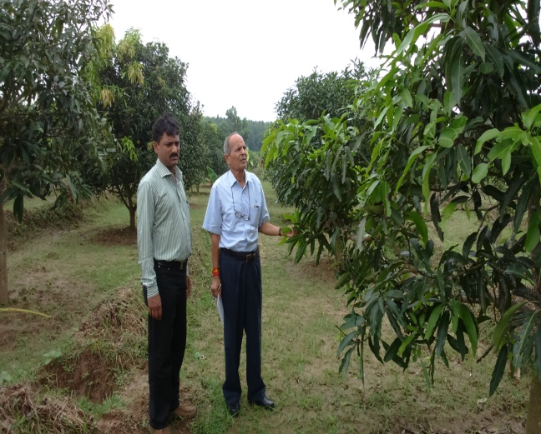 | 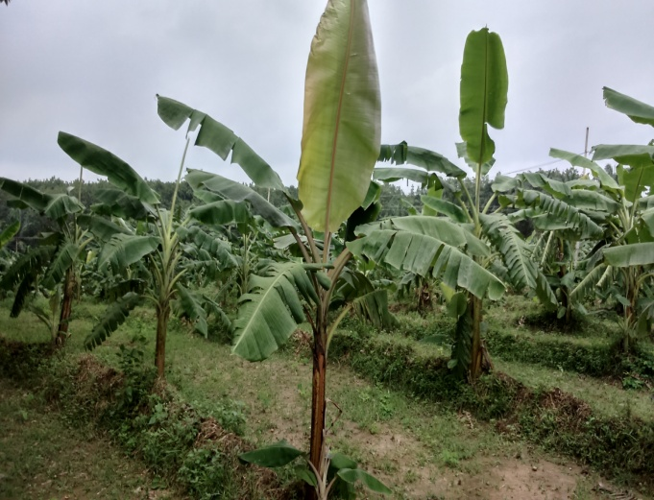
Area expansion of mango | Area expansion of banana
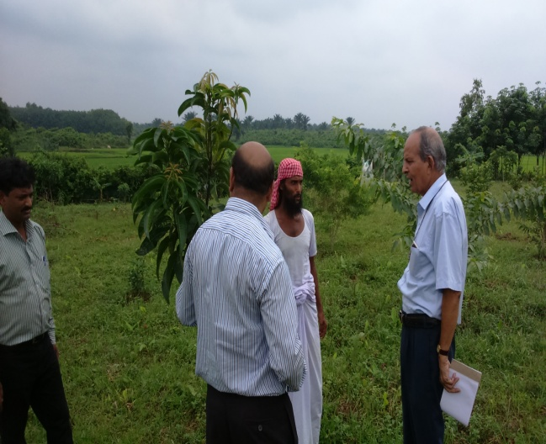 | 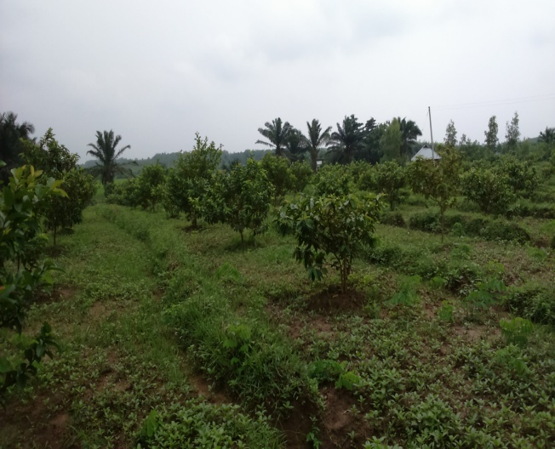
Discussion with Mohd. Haneef Miyan, grower | Intercrop in mango
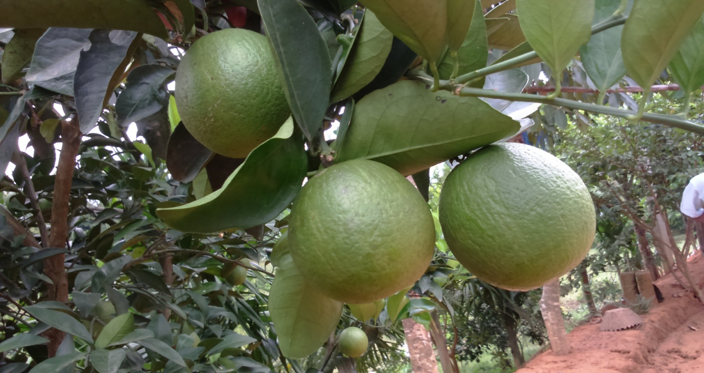
Sweet orange in fruiting

